

Technical Safety Concept Lane Assistance

**Document Version: [Version]**

**Template Version 1.0, Released on 2017-06-21**

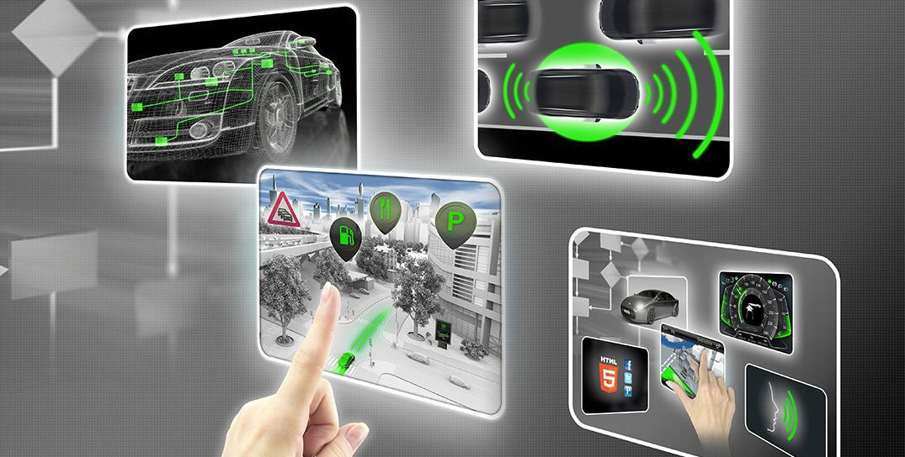

# Document history

|  |  |  |  |
| --- | --- | --- | --- |
| Date | Version | Editor | Description |
| 21/6/2018 | 1.0 | Aditya |  |
|  |  |  |  |
|  |  |  |  |
|  |  |  |  |
|  |  |  |  |

# 

# Table of Contents

Document history

Table of Contents

Purpose of the Technical Safety Concept

Inputs to the Technical Safety Concept

Functional Safety Requirements

Refined System Architecture from Functional Safety Concept

Functional overview of architecture elements

Technical Safety Concept

Technical Safety Requirements

Refinement of the System Architecture

Allocation of Technical Safety Requirements to Architecture Elements

Warning and Degradation Concept

# 

# Purpose of the Technical Safety Concept

# Inputs to the Technical Safety Concept

## Functional Safety Requirements

|  |  |  |  |  |
| --- | --- | --- | --- | --- |
| **ID** | **Functional Safety Requirement** | **ASIL** | **Fault Tolerant Time Interval** | **Safe State** |
| Functional  Safety  Requirement  01-01 | The electronic power steering ECU shall ensure that the lane departure warning oscillating torque amplitude is below Max_Torque_Amplitude | C | 50 ms | LDW function is not activated |
| Functional  Safety  Requirement  01-02 | The electronic power steering ECU shall ensure that the lane departure warning oscillating torque amplitude is below Max_Torque_Frequency | C | 50 ms | LDW function is not activated |
| Functional  Safety  Requirement  02-01 | The electronic power steering ECU shall ensure that the lane keeping assistance torque is applied only for Max_Duration | B | 500 ms | LKA function is not activated |

## Refined System Architecture from Functional Safety Concept

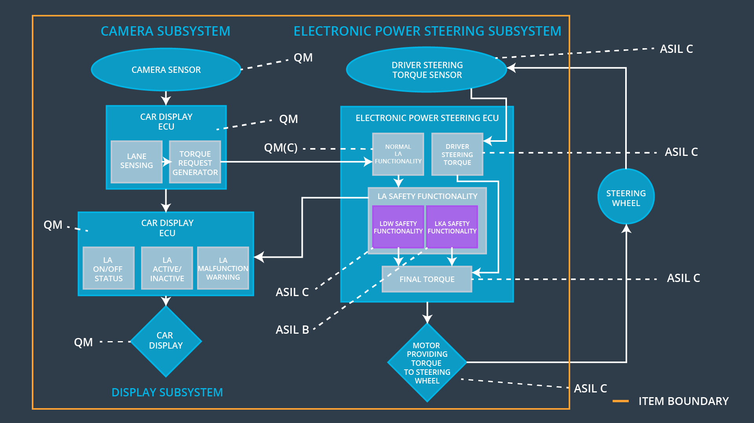

### Functional overview of architecture elements

|  |  |
| --- | --- |
| **Element** | **Description** |
| Camera Sensor | Provides images of road to camera sensor ECU. |
| Camera Sensor ECU - Lane Sensing | Detects the lane lines in camera images. |
| Camera Sensor ECU - Torque request generator | Generates an torque request to the Electronic Power Steering ECU. |
| Car Display | Shows warning to the driver. |
| Car Display ECU - Lane Assistance On/Off Status | Indicates if LKA is turned on. |
| Car Display ECU - Lane Assistant Active/Inactive | Indicates if LKA has properly detected lanes and is active at the moment. |
| Car Display ECU - Lane Assistance malfunction warning | Indicates malfunctioning of LKA. |
| Driver Steering Torque Sensor | Measures the torque applied by the driver on the steering wheel. |
| Electronic Power Steering (EPS) ECU - Driver Steering Torque | Process input from Driver Steering Torque Sensor. |
| EPS ECU - Normal Lane Assistance Functionality | This module receives the torque request from Camera Sensor ECU. |
| EPS ECU - Lane Departure Warning Safety Functionality | Ensures torque amplitude is below Max_Torque_Amplitude and torque frequency is below Max_Torque_Frequency |
| EPS ECU - Lane Keeping Assistant Safety Functionality | Ensures is LKA is not active for more than Max_Duration time. |
| EPS ECU - Final Torque | Combines the torque request from LKA and LDW functionalities and sends it to the Motor. |
| Motor | Applies the required torque to the steering wheel. |

# Technical Safety Concept

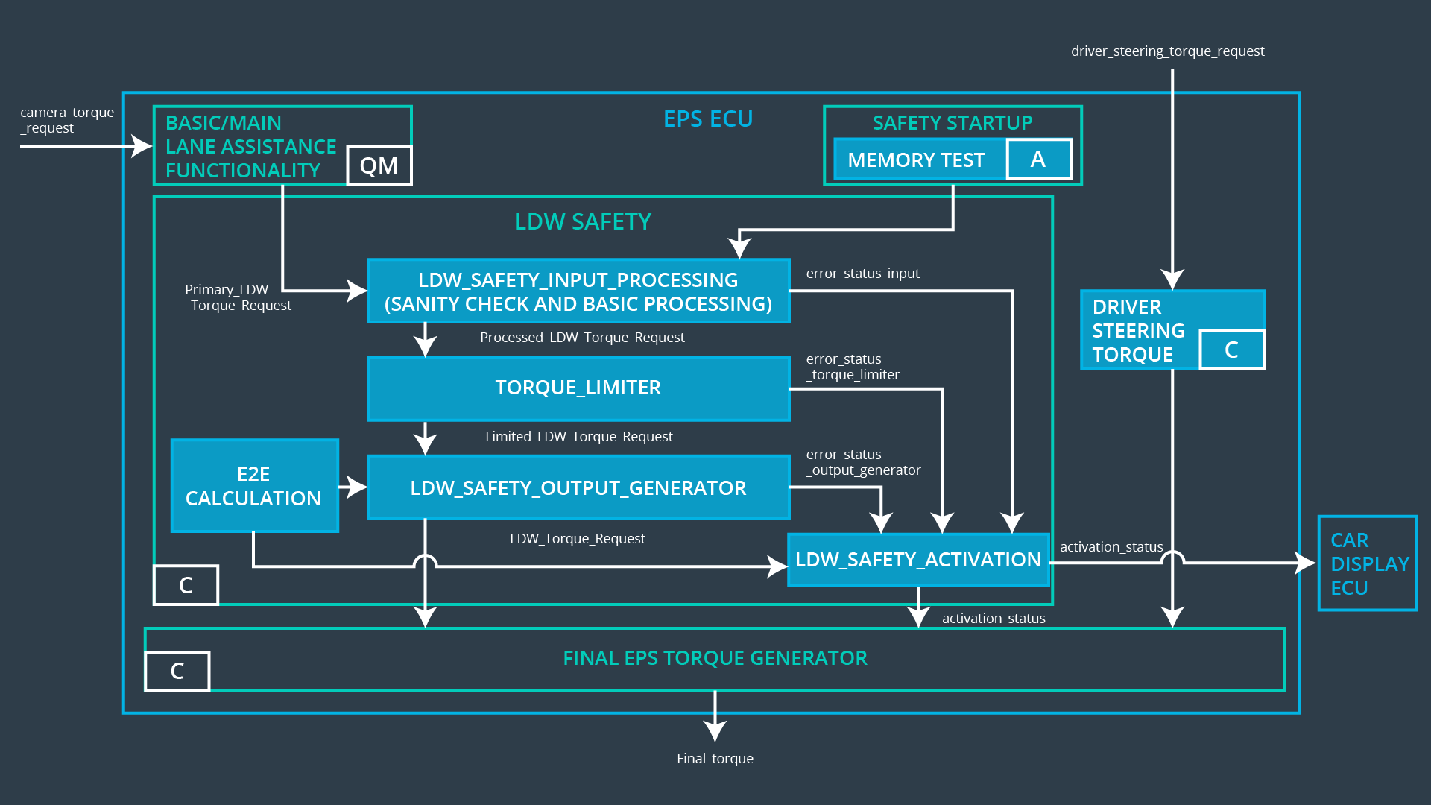

## Technical Safety Requirements

**Lane Departure Warning (LDW) Requirements:**

Functional Safety Requirement 01-01 with its associated system elements

(derived in the functional safety concept)

|  |  |  |  |  |
| --- | --- | --- | --- | --- |
| **ID** | **Functional Safety Requirement** | **Electronic Power Steering ECU** | **Camera ECU** | **Car Display ECU** |
| Functional  Safety  Requirement  01-01 | The lane keeping item shall ensure that the lane departure oscillating torque amplitude is below Max_Torque_Amplitude | X |  |  |

Technical Safety Requirements related to Functional Safety Requirement 01-01 are:

|  |  |  |  |  |  |
| --- | --- | --- | --- | --- | --- |
| **ID** | **Technical Safety Requirement** | **ASIL** | **Fault Tolerant Time Interval** | **Architecture Allocation** | **Safe State** |
| Technical  Safety  Requirement  01 | LDW safety component shall ensure that the amplitude of the LDW_Torque_Request sent to the *Final Electronic Power Steering Torque* component is below Max_Torque_Amplitude | C | 50ms | LDW Safety Block | The lane departure warning torque request amplitude shall be set to zero |
| Technical  Safety  Requirement  02 | Validity and Integrity of the data transmission for the LDW_Torque_Request signal shall be ensured | C | 50ms | Data Transmission Integrity Check |
| Technical  Safety  Requirement  03 | As soon as a failure is detected by the LDW function, it shall deactivate the LDW feature and the LDW_Torque_Request shall be set to zero. | C | 50ms | LDW Safety Block |
| Technical  Safety  Requirement  04 | As soon as the LDW function deactivates the LDW feature, the LDW safety software block shall send a signal to the car display ECU to turn on a warning light. | C | 50ms | LDW Safety Block |
| Technical  Safety  Requirement  05 | Memory test shall be conducted at the startup of EPS ECU to check for any faults in memory. | A | Ignition cycle | Separate External block with Memory test code |

Functional Safety Requirement 01-2 with its associated system elements

(derived in the functional safety concept)

|  |  |  |  |  |
| --- | --- | --- | --- | --- |
| **ID** | **Functional Safety Requirement** | **Electronic Power Steering ECU** | **Camera ECU** | **Car Display ECU** |
| Functional  Safety  Requirement  01-02 | The lane keeping item shall ensure that the lane departure oscillating torque frequency is below Max_Torque_Frequency | X |  |  |

Technical Safety Requirements related to Functional Safety Requirement 01-02 are:

|  |  |  |  |  |  |
| --- | --- | --- | --- | --- | --- |
| **ID** | **Technical Safety Requirement** | **ASIL** | **Fault Tolerant Time Interval** | **Architecture Allocation** | **Safe State** |
| Technical  Safety  Requirement  01 | LDW safety component shall ensure that the frequency of the LDW_Torque_Request sent to the *Final Electronic Power Steering Torque* component is below Max_Torque_Frequency | C | 50ms | LDW Safety Component | The lane departure warning torque request amplitude shall be set to zero |
| Technical  Safety  Requirement  02 | Validity and Integrity of the data transmission for the LDW_Torque_Request signal shall be ensured | C | 50ms | Data Transmission Integrity Check |
| Technical  Safety  Requirement  03 | As soon as a failure is detected by the LDW function, it shall deactivate the LDW feature and the LDW_Torque_Request shall be set to zero. | C | 50ms | LDW Safety Component |
| Technical  Safety  Requirement  04 | As soon as the LDW function deactivates the LDW feature, the LDW safety software block shall send a signal to the car display ECU to turn on a warning light. | C | 50ms | LDW Safety Component |
| Technical  Safety  Requirement  05 | Memory test shall be conducted at the startup of EPS ECU to check for any faults in memory. | A | Ignition Cycle | Separate External block with Memory test code |

**Lane Keeping Assistance (LKA) Requirements:**

Functional Safety Requirement 02-1 with its associated system elements

(derived in the functional safety concept)

|  |  |  |  |  |
| --- | --- | --- | --- | --- |
| **ID** | **Functional Safety Requirement** | **Electronic Power Steering ECU** | **Camera ECU** | **Car Display ECU** |
| Functional  Safety  Requirement  02-01 | The lane keeping item shall ensure that the lane keeping assistance torque is applied for only Max_Duration | X |  |  |

Technical Safety Requirements related to Functional Safety Requirement 02-01 are:

|  |  |  |  |  |  |
| --- | --- | --- | --- | --- | --- |
| **ID** | **Technical Safety Requirement** | **ASIL** | **Fault Tolerant Time Interval** | **Allocation to Architecture** | **Safe State** |
| Technical  Safety  Requirement  01 | LKA safety component shall ensure that the duration of the LKA_Torque_Request sent to the *Final Electronic Power Steering Torque* component is below Max_Torque_Duration | B | 500ms | LKA safety component | The lane departure warning torque request amplitude shall be set to zero |
| Technical  Safety  Requirement  02 | Validity and Integrity of the data transmission for the LKA_Torque_Request signal shall be ensured | B | 500ms | Data Transmission Integrity Check |
| Technical  Safety  Requirement  03 | As soon as a failure is detected by the LKA function, it shall deactivate the LKA feature and the LKA_Torque_Request shall be set to zero. | B | 500ms | LKA safety component |
| Technical  Safety  Requirement  04 | As soon as the LKA function deactivates the LKA feature, the LKA safety software block shall send a signal to the car display ECU to turn on a warning light. | B | 500ms | LKA safety component |
| Technical  Safety  Requirement  05 | Memory test shall be conducted at the startup of EPS ECU to check for any faults in memory. | A | Ignition Cycle | Separate External block with Memory test code |

## Refinement of the System Architecture



## Allocation of Technical Safety Requirements to Architecture Elements

For this particular item, all technical safety requirements are allocated to the Electronic Power Steering ECU

## Warning and Degradation Concept

The warning and degradation concept is the same for the technical safety requirements as for the functional safety requirements.

In both the cases (Lane Departure Warning and Lane Keeping Assistance):

|  |  |
| --- | --- |
| Warning | Warning light displayed to the driver on the dashboard |
| Degradation | Turn off functionality |